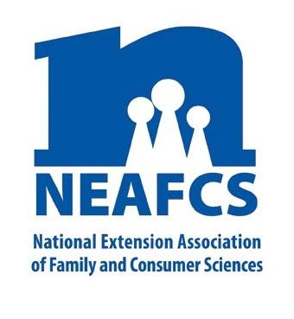
IMPACT 2014

Through Extension programs across the nation, Family and Consumer Science Extension Educators provide a multitude of educational opportunities to meet the needs of diverse audiences.

Food Safety

According to the Center for Disease Control (CDC) one in six Americans get sick or are hospitalized each year while 3,000 die from food borne illness. The CDC notes that consumers can protect themselves by following basic precautions (separate, chill and clean) while preparing food and by reporting suspected cases of food borne illness. Extension FCS educators help everyone from home cooks to restaurateurs keep food safe from farm to table.
Food Preservation and Safety for Individuals and Families
In Colorado, 543 trainings instructed 51,350 individuals on home food preservation, proper hand washing, and pressure canner gauge inspection. Over 1,000 participants reported they intended to adopt safe home food preservation practices. Missouri Extension offered 20 food preservation programs to over 330 individuals. Over 900 Ohio consumers in 24 counties participated in home food preservation classes.
The 153 individuals that participated in Maine’s Cooking for Crowds workshops learned how to reduce food borne illness through safe food handling techniques. Georgia provided over 354 hours of food preservation classes and reached over 2100 adults and youth.
In New York, 132 Master Food Preservers were trained and 114 food preservation classes attracted 1,278 attendees. Likewise, 434 new and veteran Master Food Preserver volunteers in Oregon contributed over 39,670 hours in 14 counties making 420,612
NEAFCS National Office | 20423 State Road 7, Suite F6-491 | Boca Raton, FL 33498
(561) 477-8100 | FAX (561) 910-0896 | www.neafcs.org
contacts by phone, at workshops, county fairs, farmer's markets, other events, media interviews, and public demonstrations.
Thirty-five food preservation classes provided 296 Wyoming residents with proper food preservation techniques at high elevation.
Entrepreneurial Food Safety
A Food Preservation Basics Train-the-Trainer for Tribal Colleges and Communities workshop provided resources and local expertise to five Minnesota Native American communities. Minnesota educators also presented entrepreneurs and market vendors with classes on pickle safety, jam/jelly making & marketing, and produce preservation tips aimed at customers.

“I was naive to the dangers that food posed and the many practices that could be used to make sure food was safe. The course was a wonderful learning experience and I would even recommend it to people who just cook in their kitchen.” – Minnesota School
Food Service Director

South Dakota FCS educators assisted more than 50 food processors expand their business by analyzing acidified food products for safety verification, and by creating
nutrition facts panels and ingredient statements for over 50 food products. In Georgia, 20 participants attended hands-on classes to explore cottage industry enterprises.

Food handlers

Michigan State University Extension offered ServSafe™ -- national certification program -- to 439 participants, with 93% passing the exam. New York offered 12 ServSafe™ courses, reaching 178 persons. Wyoming provided 11 four-hour long food safety trainings to 173 participants.

Eighty-two retail food safety workshops were held in
Indiana; 91% of the individuals employed in the food service industry that took these classes received Serv Safe ™ certification.

Pennsylvania educators trained 952 individuals from 268 non-profit organizations on safe food handling practices.

In Maryland, 24 four-hour “Food Safety is for Everyone” classes reached 618 participants. One hundred ten food safety certificates were distributed and 12 participants received two CEU’s enabling recipients to meet job requirements and remain employed while enabling participating organizations to remain in compliance with funding sources. In Delaware, a “DE Dine Safe" class was presented to 32 high school juniors and seniors taking part in a food service workforce readiness program.

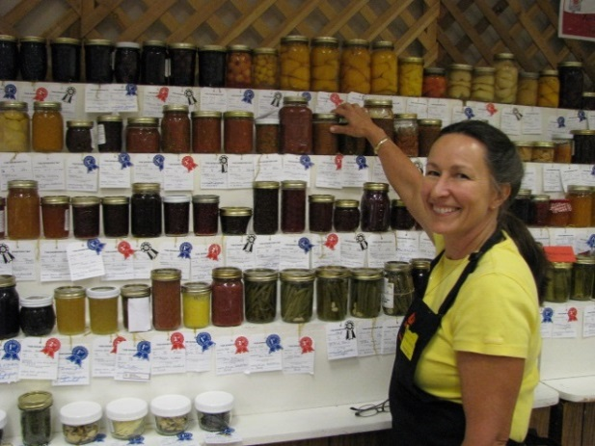
A partnership with the South Dakota Retailers Association provides ServSafe™ trainings specific to food service managers who are responsible for training staff within their food service establishment in food safety principles. Three hundred ninety-five South Dakotans in rural areas received foodservice manager sanitation

This report was compiled by Linda Combs, University of Kentucky Cooperative Extension, Public Affairs Education Subcommittee member, and Theresa Mayhew, Cornell Cooperative Extension, Vice President – Public Affairs. For more information, email tcm5@cornell.edu.

certification or recertification; two became certified ServSafe™ instructors and are serving the Cheyenne Indian Reservation. Of the 394 individuals attending the food safety certification classes, 347 persons (88%) received their certificates and 122 obtained food safety recertification status.

Marketing/Communications

Georgia’s National Center for Food Preservation website had over 1.8 million visitors in 2013 with five million page views. Over 20,000 visitors per day used the site in peak months. The Ohio State Extension Food Safety/Preservation Hotline was staffed by 57 Master Food Preservers. They fielded 2,262 calls for help and information from every county during the canning season and the two weeks before Thanksgiving.
Increased demand for food preservation education prompted Minnesota educators to create five-minute online mini-modules on 22 food preservation topics that reached 2,000 home preservers. Each module emphasized critical science-based information and steps to achieve a safe and tasty preserved product. Over 90,000 people have viewed Maine’s seven “How-To” videos on food preservation of popular local or regional foods.
In its first year, a food safety hotline in Pennsylvania responded to 204 consumer questions with 60% answered within 30 minutes, providing timely responses to food safety and home food preservation questions.

